A000-ME-Gandhara-Buddha Statue in Flames-Bronze-323 BCE

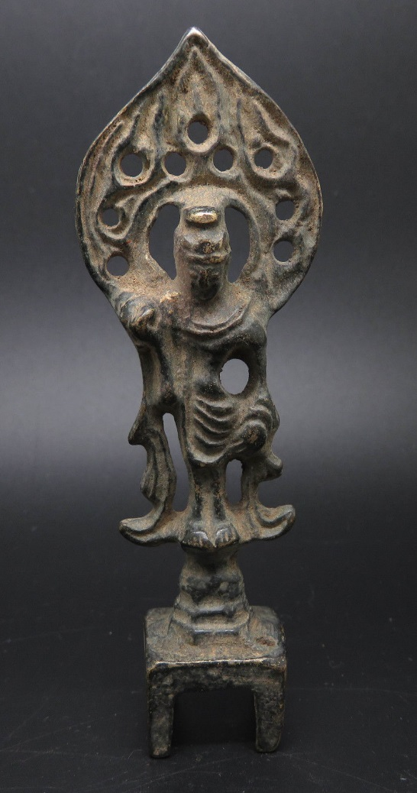 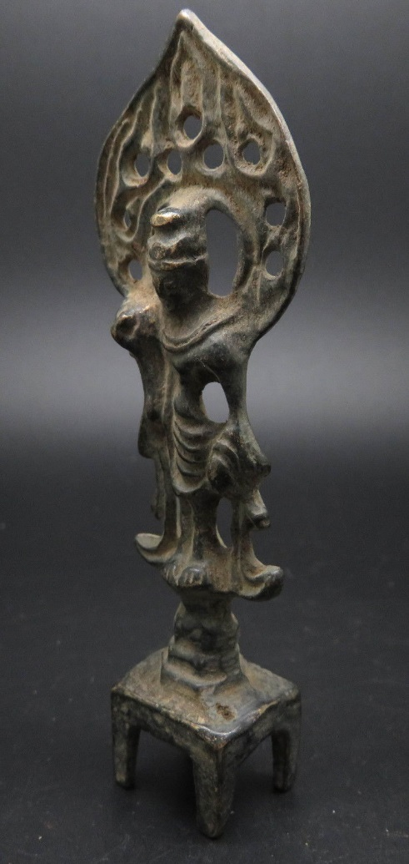 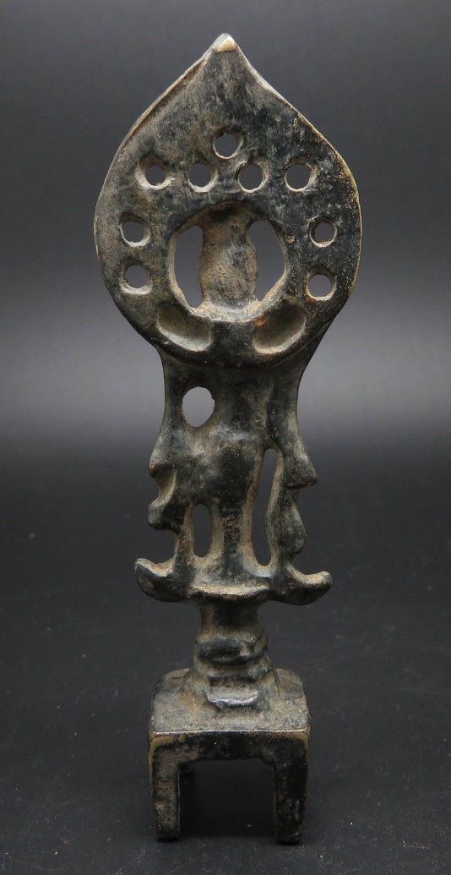

Figs. 1-3. Gandhara-Buddha Statue in Flames-Bronze-323 BCE

**Case No.: 3**

**Accession No.**

**Formal Label:** Gandhara-Buddha Statue in Flames-Bronze-323 BCE

**Display Description:**

**Gandhāra** was one of sixteen [Mahajanapada](https://en.wikipedia.org/wiki/Mahajanapada" \o "Mahajanapada) of [ancient India](https://en.wikipedia.org/wiki/Ancient_India),[[1]](https://en.wikipedia.org/wiki/Gandhara#cite_note-Devi2007-1) currently situated in modern-day northern [Pakistan](https://en.wikipedia.org/wiki/Pakistan), in the [Peshawar valley](https://en.wikipedia.org/wiki/Peshawar_valley) and [Potohar plateau](https://en.wikipedia.org/wiki/Potohar_plateau" \o "Potohar plateau), and extending to [Jalalabad](https://en.wikipedia.org/wiki/Jalalabad) district of modern-day Afghanistan. During the [Achaemenid period](https://en.wikipedia.org/wiki/Achaemenid_Empire" \o "Achaemenid Empire) and [Hellenistic period](https://en.wikipedia.org/wiki/Hellenistic_period), its capital city was [Charsadda](https://en.wikipedia.org/wiki/Charsadda" \o "Charsadda),[[note 1]](https://en.wikipedia.org/wiki/Gandhara#cite_note-2) but later the capital city was moved to Peshawar[[note 2]](https://en.wikipedia.org/wiki/Gandhara#cite_note-3) by the [Kushan](https://en.wikipedia.org/wiki/Kushan" \o "Kushan) emperor [Kanishka the Great](https://en.wikipedia.org/wiki/Kanishka_the_Great" \o "Kanishka the Great) in about AD 127.

Gandhara existed since the time of the [Rigveda](https://en.wikipedia.org/wiki/Rigveda) (c. 1500–1200 BC),[[2]](https://en.wikipedia.org/wiki/Gandhara#cite_note-sacred-texts.com-4)[[3]](https://en.wikipedia.org/wiki/Gandhara#cite_note-5) as well as the Zoroastrian [Avesta](https://en.wikipedia.org/wiki/Avesta" \o "Avesta), which mentions it as *Vaēkərəta*, the sixth most beautiful place on earth, created by [Ahura Mazda](https://en.wikipedia.org/wiki/Ahura_Mazda" \o "Ahura Mazda). Gandhara was conquered by the Achaemenid Empire in the 6th century BC. Conquered by [Alexander the Great](https://en.wikipedia.org/wiki/Alexander_the_Great) in 327 BC, it subsequently became part of the [Maurya Empire](https://en.wikipedia.org/wiki/Maurya_Empire" \o "Maurya Empire) and then the [Indo-Greek Kingdom](https://en.wikipedia.org/wiki/Indo-Greek_Kingdom). The region was a major center for [Greco-Buddhism](https://en.wikipedia.org/wiki/Greco-Buddhism) under the [Indo-Greeks](https://en.wikipedia.org/wiki/Indo-Greek_Kingdom) and [Gandharan Buddhism](https://en.wikipedia.org/wiki/Gandharan_Buddhism" \o "Gandharan Buddhism) under later dynasties. It was also a central location for the spread of Buddhism to Central Asia and East Asia.[[4]](https://en.wikipedia.org/wiki/Gandhara#cite_note-6) It was also a center of [Bactrian](https://en.wikipedia.org/wiki/Bactria) [Zoroastrianism](https://en.wikipedia.org/wiki/Zoroastrianism) and [Hinduism](https://en.wikipedia.org/wiki/Hinduism).[[5]](https://en.wikipedia.org/wiki/Gandhara#cite_note-7) Famed for its local tradition of [Gandhara (Greco-Buddhist) Art](https://en.wikipedia.org/wiki/Greco-Buddhist_art" \o "Greco-Buddhist art), Gandhara attained its height from the 1st century to the 5th century under the [Kushan Empire](https://en.wikipedia.org/wiki/Kushan_Empire" \o "Kushan Empire). Gandhara "flourished at the crossroads of Asia," connecting [trade routes](https://en.wikipedia.org/wiki/Silk_Road) and absorbing cultural influences from diverse civilizations; Buddhism thrived until 8th or 9th centuries, when [Islam](https://en.wikipedia.org/wiki/Islam) first began to gain sway in the region.[[6]](https://en.wikipedia.org/wiki/Gandhara#cite_note-8) Pockets of Buddhism persisted in Pakistan's [Swat valley](https://en.wikipedia.org/wiki/Swat_valley) until the 11th century.[[7]](https://en.wikipedia.org/wiki/Gandhara#cite_note-:0-9)

Gandhara was known in [Sanskrit](https://en.wikipedia.org/wiki/Sanskrit) as गन्धार *gandhāra*, in [Avestan](https://en.wikipedia.org/wiki/Avestan" \o "Avestan) as *Vaēkərəta*, in [Old Persian](https://en.wikipedia.org/wiki/Old_Persian) as *Para-upari-sena*, in [Chinese](https://en.wikipedia.org/wiki/Chinese_Language) as 犍陀罗, and in [Greek](https://en.wikipedia.org/wiki/Ancient_Greek) as Παροπαμισάδαι *Paropamisadae*.

The [Gandhari people](https://en.wikipedia.org/wiki/Gandhari_people" \o "Gandhari people) are a [tribe](https://en.wikipedia.org/wiki/List_of_Rigvedic_tribes) mentioned in the [Rigveda](https://en.wikipedia.org/wiki/Rigveda), the [Atharvaveda](https://en.wikipedia.org/wiki/Atharvaveda), and later Vedic texts.[[11]](https://en.wikipedia.org/wiki/Gandhara#cite_note-13) They are recorded in the [Avestan](https://en.wikipedia.org/wiki/Avestan" \o "Avestan)-language of [Zoroastrianism](https://en.wikipedia.org/wiki/Zoroastrianism) under the name *Vaēkərəta*. The name *Gāndhāra* occurs later in the [classical Sanskrit](https://en.wikipedia.org/wiki/Classical_Sanskrit) of the [epics](https://en.wikipedia.org/wiki/Sanskrit_epics). One proposed origin of the name is from the Sanskrit word *gandha*, meaning "perfume" and "referring to the spices and aromatic herbs which they [the inhabitants] traded and with which they anointed themselves.".[[12]](https://en.wikipedia.org/wiki/Gandhara" \l "cite_note-14)[[13]](https://en.wikipedia.org/wiki/Gandhara#cite_note-15)

A [Persian](https://en.wikipedia.org/wiki/Persian_language) form of the name, *Gandara*, appearing in the [Behistun inscription](https://en.wikipedia.org/wiki/Behistun_inscription" \o "Behistun inscription) of Emperor [Darius I](https://en.wikipedia.org/wiki/Darius_I),[[14]](https://en.wikipedia.org/wiki/Gandhara#cite_note-16) is also mentioned by [Herodotus](https://en.wikipedia.org/wiki/Herodotus)[[15]](https://en.wikipedia.org/wiki/Gandhara#cite_note-17) in the context of the story of the Greek explorer [Scylax of Caryanda](https://en.wikipedia.org/wiki/Scylax_of_Caryanda" \o "Scylax of Caryanda), who sailed down the Indus River starting at the city of *Caspatyrus* in *Gandara*(Κασπάτυρος, πόλις Γανδαρική). Herodotus records that those [Iranic](https://en.wikipedia.org/wiki/Iranian_peoples" \o "Iranian peoples) tribes, which were adjacent to the city of Caspatyrus and the district of Pactyïce, had customs similar to the [Bactrians](https://en.wikipedia.org/wiki/Bactria), and are the most warlike amongst them. These are also the people who obtain gold from the ant-hills of the adjoining desert. On the identity of Caspatyrus, there have been two opinions, one equating it with [Kabul](https://en.wikipedia.org/wiki/Kabul), the other with the name of [Kashmir](https://en.wikipedia.org/wiki/Kashmir) (*Kasyapa pur*, condensed to *Kaspapur* as found in [Hecataeus](https://en.wikipedia.org/wiki/Hecataeus_of_Miletus" \o "Hecataeus of Miletus)).[[16]](https://en.wikipedia.org/wiki/Gandhara#cite_note-18)

The main Vedic tribes remaining in the [Indus Valley](https://en.wikipedia.org/wiki/Indus_Valley) by 550 BC were the *Kamboja*, *Sindhu*, *Taksas* of Gandhara, the *Madras* and *Kathas* of the [River Chenab](https://en.wikipedia.org/wiki/River_Chenab), *Mallas* of the [River Ravi](https://en.wikipedia.org/wiki/River_Ravi) and *Tugras* of the [River Sutlej](https://en.wikipedia.org/wiki/River_Sutlej). These several tribes and principalities fought against one another to such an extent that the Indus Valley no longer had one powerful Vedic tribal kingdom to defend against outsiders and to wield the warring tribes into one organized kingdom. The area was wealthy and fertile, yet infighting led misery and despair. King Pushkarasakti of Gandhara was engaged in power struggles against his local rivals and as such the [Khyber Pass](https://en.wikipedia.org/wiki/Khyber_Pass) remained poorly defended. [King Darius I](https://en.wikipedia.org/wiki/King_Darius_I) of the [Achaemenid Empire](https://en.wikipedia.org/wiki/Achaemenid_Empire" \o "Achaemenid Empire) took advantage of the opportunity and planned for an invasion. The Indus Valley was fabled in Persia for its gold and fertile soil and conquering it had been a major objective of his predecessor [Cyrus The Great](https://en.wikipedia.org/wiki/Cyrus_The_Great).[[19]](https://en.wikipedia.org/wiki/Gandhara#cite_note-21) In 542 BC, Cyrus had led his army and conquered the Makran coast in southern [Balochistan](https://en.wikipedia.org/wiki/Balochistan" \o "Balochistan). However, he is known to have campaigned beyond Makran (in the regions of [Kalat](https://en.wikipedia.org/wiki/Kalat,_Pakistan" \o "Kalat, Pakistan), [Khuzdar](https://en.wikipedia.org/wiki/Khuzdar" \o "Khuzdar), [Panjgur](https://en.wikipedia.org/wiki/Panjgur" \o "Panjgur)) and lost most of his army in the *Gedrosian Desert* (speculated today as the [Kharan Desert](https://en.wikipedia.org/wiki/Kharan_Desert" \o "Kharan Desert)).

In 518 BC, Darius led his army through the Khyber Pass and southwards in stages, eventually reaching the [Arabian Sea](https://en.wikipedia.org/wiki/Arabian_Sea) coast in Sindh by 516 BC. Under Persian rule, a system of centralized administration, with a bureaucratic system, was introduced into the Indus Valley for the first time. Provinces or "satrapy" were established with provincial capitals:

[**Gandhara**](https://en.wikipedia.org/wiki/Gandhara#Part_of_Achaemenid_Empire)**satrapy**, established 518 BC with its capital at [Pushkalavati](https://en.wikipedia.org/wiki/Pushkalavati" \o "Pushkalavati) ([Charsadda](https://en.wikipedia.org/wiki/Charsadda" \o "Charsadda)).[[20]](https://en.wikipedia.org/wiki/Gandhara#cite_note-22) Gandhara Satrapy was established in the general region of the old Gandhara grave culture, in what is today [Khyber Pakhtunkhwa](https://en.wikipedia.org/wiki/Khyber_Pakhtunkhwa). During Achaemenid rule, the [Kharosthi](https://en.wikipedia.org/wiki/Kharosthi" \o "Kharosthi) alphabet, derived from the one used for Aramaic (the official language of Achaemenids), developed here and remained the national script of Gandhara until 200 AD.

The inscription on Darius' (521–486 BC) tomb at [Naqsh-i-Rustam](https://en.wikipedia.org/wiki/Naqsh-e_Rustam" \o "Naqsh-e Rustam) near Persepolis records Gadāra (Gandāra) along with [Hindush](https://en.wikipedia.org/wiki/Hindush" \o "Hindush) (Hənduš, Sindh) in the list of *satrapies*. By about 380 BC the Persian hold on the region had weakened. Many small kingdoms sprang up in Gandhara. In 327 BC, [Alexander the Great](https://en.wikipedia.org/wiki/Alexander_the_Great) conquered Gandhara as well as the Indian *satrapies* of the Persian Empire. The expeditions of Alexander were recorded by his court historians and by [Arrian](https://en.wikipedia.org/wiki/Arrian" \o "Arrian) (around AD 175) in his [*Anabasis Alexandri*](https://en.wikipedia.org/wiki/Anabasis_Alexandri) and by other chroniclers many centuries after the event.

Sir [Mortimer Wheeler](https://en.wikipedia.org/wiki/Mortimer_Wheeler) conducted some excavations there in 1962, and identified various [Achaemenid](https://en.wikipedia.org/wiki/Achaemenid" \o "Achaemenid) remains.

**Alexander the Great and Gandhara**

In the winter of 327 BC, Alexander invited all the chieftains in the remaining five Achaemenid satraps to submit to his authority. [Ambhi](https://en.wikipedia.org/wiki/Ambhi" \o "Ambhi), then ruler of Taxila in the former [Hindush](https://en.wikipedia.org/wiki/Hindush" \o "Hindush) satrapy complied, but the remaining tribes and clans in the former satraps of Gandhara, Arachosia, Sattagydia and Gedrosia rejected Alexander's offer.

The first tribe they encountered were the [Aspasioi](https://en.wikipedia.org/wiki/Aspasioi" \o "Aspasioi) tribe of the [Kunar Valley](https://en.wikipedia.org/wiki/Kunar_Valley" \o "Kunar Valley), who initiated a fierce battle against Alexander, in which he himself was wounded in the shoulder by a dart. However, the Aspasioi eventually lost and 40,000 people were enslaved. Alexander then continued in a southwestern direction where he encountered the [Assakenoi](https://en.wikipedia.org/wiki/Assakenoi" \o "Assakenoi) tribe of the [Swat](https://en.wikipedia.org/wiki/Swat,_Pakistan) & [Buner](https://en.wikipedia.org/wiki/Buner) valleys in April 326 BC. The Assakenoi fought bravely and offered stubborn resistance to Alexander and his army in the cities of Ora, Bazira ([Barikot](https://en.wikipedia.org/wiki/Barikot" \o "Barikot)) and Massaga. So enraged was Alexander about the resistance put up by the Assakenoi that he killed the entire population of Massaga and reduced its buildings to rubble. A similar slaughter then followed at Ora[[21]](https://en.wikipedia.org/wiki/Gandhara" \l "cite_note-23), another stronghold of the Assakenoi. The stories of these slaughters reached numerous Assakenians, who began fleeing to Aornos, a hill-fort located between [Shangla](https://en.wikipedia.org/wiki/Shangla" \o "Shangla) and [Kohistan](https://en.wikipedia.org/wiki/Kohistan_District,_Pakistan). Alexander followed close behind their heels and besieged the strategic hill-fort, eventually capturing and destroying the fort and killing everyone inside. The remaining smaller tribes either surrendered or like the [Astanenoi](https://en.wikipedia.org/w/index.php?title=Astanenoi&action=edit&redlink=1" \o "Astanenoi (page does not exist)) tribe of [Pushkalavati](https://en.wikipedia.org/wiki/Pushkalavati" \o "Pushkalavati) ([Charsadda](https://en.wikipedia.org/wiki/Charsadda" \o "Charsadda)) were quickly neutralized where 38,000 soldiers and 230,000 oxen were captured by Alexander.[[22]](https://en.wikipedia.org/wiki/Gandhara#cite_note-24)Eventually Alexander's smaller force would meet with the larger force which had come through the Khyber Pass met at [Attock](https://en.wikipedia.org/wiki/Attock" \o "Attock). With the conquest of Gandhara complete, Alexander switched to strengthening his military supply line, which by now stretched dangerously vulnerable over the [Hindu Kush](https://en.wikipedia.org/wiki/Hindu_Kush) back to [Balkh](https://en.wikipedia.org/wiki/Balkh) in Bactria.

After conquering Gandhara and solidifying his supply line back to Bactria, Alexander combined his forces with the King Ambhi of Taxila and crossed the River Indus in July 326 BC to begin the Archosia (Punjab) campaign. Alexander founded several new settlements in Gandhara, [Punjab](https://en.wikipedia.org/wiki/Punjab_(Pakistan)) and [Sindh](https://en.wikipedia.org/wiki/Sindh).[[23]](https://en.wikipedia.org/wiki/Gandhara#cite_note-25) and nominated officers as Satraps of the new provinces:

In Gandhara, [Oxyartes](https://en.wikipedia.org/wiki/Oxyartes" \o "Oxyartes) was nominated to the position of Satrap by Alexander in 326 BC.

**Accession Number:**

**LC Classification**: [NB992.2.K36](http://josiah.brown.edu/search~S7?/c2-SIZE+NB992.2.K36+B87+1978/cnb++992.2+k36+b87+1978/-3%2C-1%2C0%2CE/frameset&FF=cnb++992.2+k36+b87+1978&1%2C1%2C)

**Date or Time Horizon:** Kushan Period-4th Century

**Geographical Area:** Taxila, Gandhara (modern location: Rawalpindi District, Punjab, Pakistan)

|  |  |
| --- | --- |
|  |  |

**Map, GPS coordinates:** [33°44′45″N 72°47′15″E](https://tools.wmflabs.org/geohack/geohack.php?pagename=Taxila&params=33_44_45_N_72_47_15_E_region:PK_type:landmark)

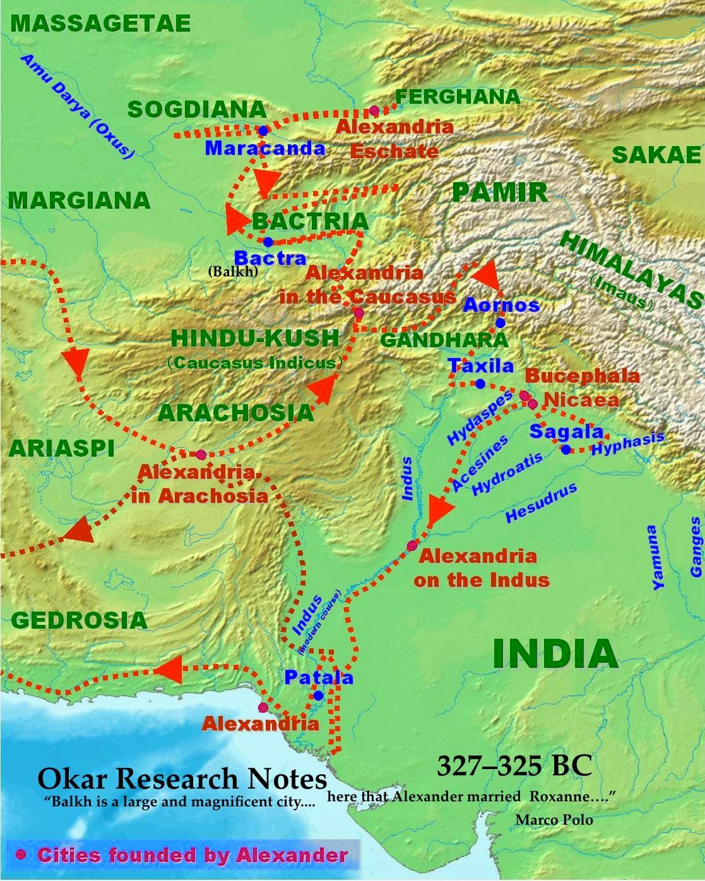

Fig. 4. Map of Gandhara and area where Alexander founded cities and where Buddhist statues have been found from http://2.bp.blogspot.com/-ykxrKlxxjkg/U5rg7JPM\_RI/AAAAAAAAC9o/CvRbz8pUfbc/s1600/AlexanderConquestsInIndia.jpg

**Cultural Affiliation:** Gandhara

**Medium:** schist.

**Dimensions:** H 100.32 mm

**Weight:**

**Condition: original**

**Provenance:** unknown

**Discussion:**

Taxila (Greek for Takshashila,”Rock of Taksha”) in Indian and Greco-Roman accounts and by Chinese Buddhist pilgrims, Faxian and Xuanzang as the prosperous and well-governed capital of the kingdom of Gandhara and as a great center of learning. In 326 BCE, Ambhi (Omphis), the ruler of Taxila, surrendered the city to Alexander and placed his resources at Alexander’s disposal.

**References:**

Allchin, Bridget and Raymond Allchin. 1988. *The rise of civilization in India and Pakistan.* Cambridge: Cambridge University Press.

Allchin, F. Raymond. 1993. "The Urban Position of Taxila and Its Place in Northwest India-Pakistan," *Studies in the History of Art*, 31: 69–81.

Cunningham, Alexander. 1871. *The Ancient Geography of India: The Buddhist Period, Including the Campaigns of Alexander, and the Travels of Hwen-Thsang*. Cambridge: Cambridge University Press.

Marshall, John. 1960. *A guide to Taxila* (4th ed.). Cambridge: Cambridge University Press.

Marshall, John. 1951. *Taxila: an illustrated account of archaeological excavations carried out at Taxila under the orders of the Government of India between the years 1913 and 1914*. 3 v. Delhi: Barnasidass.